**WolfHospital Database Management System**

For a hospital in North Carolina

CSC 540 Database Systems

Project Report #2

Project Team Member:

Xiaoting Fu, Yifan Zhao, Xiao Ma, Xuejiao Fang

# **Assumptions and Problem Statement**

Assumptions

1. One ward can only be assigned to one patient, no matter how many beds the ward has (similar to hotel booking schema, 1-bed-room and 2-beds rooms can only be booked by one customer).
2. Each patient needs to check-in and be assigned a ward no matter if the patient going to stay overnight or not
3. One nurse can be responsible for multiple wards and when assigning a nurse to a ward the system will select a nurse who has the least number ward that he/she is in charge of.
4. The ward can be used for patient to rest or doctor to give treatment
5. Staff can be subdivided into Doctors, Nurses and Operators
6. Only Doctors have professional title
7. One check-in can accept many treatments, each treatment generates a medical record.
8. When a patient arrives at the hospital, he will provide his requirement for a ward, if the ward exists, he will create an account otherwise his account is not created.
9. When creating a new patient account, his billing account created at the same time.
10. A billing record is created in the following three cases: when a new medical record is created, when a registration fee is generated and when the accommodation fee is generated.

# 1) Database Schema

* Patients(PID, SSN, Name, DoB, Gender, Age, Status, Address, PhoneNum)
* Wards(WNum, Capacity, ChargePerDay,Occupied)
* Staff(SID, Name, Age, Gender, JobTitle, ProfTitle, Department, Address, PhoneNum, Type)
* BillingAccounts(PID, BillingAddr, CreatedDate, Balance)
* BillingRecords(RID, MID, CreatedDate)
* PaymentMethods(CardNum,Type, CardValidDate)
* MedicalRecord(MID, RecordType,StartDate, EndDate, Prescription, Diagnosis)
* MedRecordOf(PID,MID)
* ResponsibleFor(MID, SID)
* CheckIn(PID, WNum, StartDate, EndDate, BedNum)
* AssignedTo(SID, WNum)
* Select(PMID, PID)
* Add(RID, PID)

The schemas are all in 3NF because all entities have unique IDs associated with them which makes it easier to identify a specific tuple.

All functional dependencies are obvious because of the IDs associated with all entities.

*Patients*(PID, SSN, Name, DoB, Gender, Age, Status, Address, PhoneNum)

The only FD is **PID->SSN, Name, DoB, Gender, Age, Status, Address, PhoneNum** which holds because each individual patient, identified by a unique PID, has an SSN, name, date of birth, gender, age, status, address and phone number.

This relation is in BCNF because PID is a key.

*Wards*(WNum, Capacity, ChargePerDay,Occupied)

The only FD is **WNum->Capacity, ChargePerDay ,Occupied** holds because each ward, identified by a unique ward number, has capacity and the charge per day.

This relation is in BCNF because WNum is a key.

*Staff*(SID, Name, Age, Gender, JobTitle, ProfTitle, Department, Address, PhoneNum, Type)

The only FD is **SID ->  Name, Age, Gender, JobTitle, ProfTitle, Department, Address, PhoneNum, Type** holds because each staff, identified by a unique SID,  has a name, age, gender, job title, professional title, department, address, phone number, type.

This relation is in BCNF because SID is a key.

*BillingAccounts*(PID, BillingAddr, CreatedDate, Balance)

The only FD is **PID -> BillingAddr, CreatedDate, Balance** holds because each patient is identified by the unique PID, has a billingAddr, CreatedDate and balance.

This relation is in BCNF because PID is a key.

*BillingRecords*(RID, MID, CreatedDate)

The only FD is **RID->MID, CreatedDate** holds because each billing record is identified by the unique RID, and its corresponding MID and the date the record created.

This relation is in BCNF because RID is a key.

*PaymentMethods*(CardNum, Type, , CardValidDate)

**CardNum -> Type, CardNum, CardValidDate** holds because each payment method is identified by both PMID, and has PMName, CardNum, and CardValidDate.

This relation is in BCNF because PMID and PID are keys.

*MedicalRecord*(MID, RecordType, StartDate, EndDate, Prescription, Diagnosis)

**MID ->StartDate, EndDate, RecordType, Prescription, Diagnosis** holds because each medical record is identified by MID, and has StartDate, EndDate, Prescription, Diagnosis.

This relation is in BCNF because MID is a key.

*CheckIn*(PID, WNum, StartDate, EndDate, BedNum)

**PID, WNum -> StartDate, EndDate, BedNum**

This relation is in BCNF because PID and WNum are keys.

*AssignedTo*(SID, WNum)

**SID, WNum -> SID, WNum**

This relation is in BCNF (and thus 3NF) because it contains two key attributes.

*ResponsibleFor*(MID, SID)

**MID, SID -> MID, SID**

This relation is in BCNF (and thus 3NF) because it contains three key attributes.

*Select*(PMID, PID)

**PMID, PID-> PMID, PID**

This relation is in BCNF (and thus 3NF) because it contains one key attribute.

*Add*(RID, PID)

**RID, PID -> RID, PID**

This relation is in BCNF (and thus 3NF) because it contains two key attributes.

*MedRecordOf*(PID,MID)

**PID, MID -> PID, MID**

This relation is in BCNF (and thus 3NF) because it contains two key attributes.

# 2) Design Decisions

The mechanical approach was used to create the global schema with a few exceptions.

* Each entity set was made into a relation with the same set of attributes
* Relationships were replaced by a relation whose attributes are the keys for the connected entity sets

All types of staff including operators, nurses, doctors are distinguished by the “type” attribute.

Many-to-one relationships were combined with other relations. Combining relations in this way makes it more efficient to answer queries that involve attributes of one relation than to answer queries involving attributes of several relations.

* combine *BillingRecords* and *Add* and add *PID* as an attribute in *BillingRecords.*
* combine *PaymentMethods* and *Select* and add *PID* as an attribute in *PaymentMethods.*
* combine *MedicalRecords* and *MedRecordOf* and add *PID* as an attribute in *MedicalRecords.*
* combine *MedicalRecords* and *ResponsibleFor*, Teatxnand add *SID* as an attribute in *MedicalRecords.*
* combine *Wards* and *AssignedTo* and add *SID* as an attribute in *Wards.*

***Patients*(PID, SSN, Name, DoB, Gender, Age, Status, Address, PhoneNum)**

* PID (Primary Key) – unique identifier
* SSN (Can be NULL) - not all patient has a SSN
* Name (NOT NULL) -  identification and diagnosis purposes
* DoB  (NOT NULL) - identification and diagnosis purposes
* Gender (NOT NULL) - identification and diagnosis purposes
* Age (NOT NULL) - identification and diagnosis purposes
* Status (NOT NULL) - must be one of  the followings: “processing treatment plan”, “in ward”, “completing treatment”
* Address (NOT NULL) - contact purpose
* PhoneNum (NOT NULL) - contact purpose

***Wards*(WNum, SID, Capacity, ChargePerDay,Occupied)**

* WNum (Primary Key) – unique identifier
* SID (Referential Integrity) - refer to other entities within the database (Staff)
* Capacity (NOT NULL) -  identification purposes
* ChargePerDay  (NOT NULL) - identification purposes, has default value
* Occupied(NOT NULl) – must be ‘Y’ or ‘N’default ‘N’

***Staff*(SID, Name, Age, Gender, JobTitle, ProfTitle, Department, Address, PhoneNum,)**

* SID (Primary Key) – unique identifier
* Name (NOT NULL) - identification purpose
* Age (NOT NULL) -  identification purpose
* Gender  (NOT NULL) - identification purpose
* JobTitle (NOT NULL) - a staff must have a job title (doctor, nurse, billing staff, etc)
* ProfTitle (Can be NULL) – a staff such as a billing staff may not have a professional title
* Department (Can be NULL) - a staff may be not assigned a department
* Address  (NOT NULL) - contact purpose
* PhoneNum (NOT NULL) - contact purpose
* Type (Primary Key) - must be one of  the followings: “nurse”, “doctor”, “operator”,”others”

***BillingAccounts*(PID, BillingAddr, CreatedDate, Balance)**

* PID (Referential Integrity, Primary Key) – unique identifier that refer to other entities within the database (Patients)
* BillingAddr (NOT NULL) -  contact purpose
* CreatedDate (NOT NULL) -  assigned current date when an account is created
* Balance  (NOT NULL) - has default 0.0

***BillingRecords*(RID, PID, MID, CreatedDate)**

* RID (Primary Key) – unique identifier
* PID (Referential Integrity) – refer to other entities within the database (Patients)
* MID (Referential Integrity) – refer to other entities within the database (MedicalRecord)
* RecordType (NOT NULL)  – refer to other entities within the database (MedicalRecord)
* CreatedDate (NOT NULL) -  assigned current date when a record is created

***PaymentMethods*(CardNum, PID, Type, CardValidDate)**

* CardNum (Primary Key) – unique identifier
* PID (Referential Integrity) – refer to other entities within the database (Patients)
* Type (NOT NULL) -  must be either ‘debit’ or ‘credit’
* CardValidDate (NOT NULL) - must be a valid card valid date for successful payments

***MedicalRecord*(MID, PID,SID, RecordType,StartDate, EndDate, Prescription, Diagnosis)**

* MID (Primary Key) – unique identifier
* PID (Referential Integrity) – refer to other entities within the database (Patients)
* SID (Referential Integrity) – refer to other entities within the database (Staff)
* StartDate (NOT NULL) -  must be assigned a start date when created
* EndDate (NOT NULL) -  must be assigned an end date when created
* RecordType(NOT NULL)- select from 'treatment','test', 'check-in', 'accommodation'
* Prescription (Can be NULL) - can be filled in later
* Diagnosis (Can be NULL) -  can be filled in later

***CheckIn*(PID, WNum, StartDate, EndDate, BedNum)**

* PID (Primary Key) – unique identifier
* WNum (Referential Integrity, Primary Key) – unique identifier that refer to other entities within the database (Wards)
* StartDate (NOT NULL) -  must be assigned a start date when created
* EndDate (NOT NULL) -  must be assigned an end date when created
* BedNum(NOT NULL) - must be assigned the desired bed number

# 3) SQL Statements

**Create Tables**

*Also seen codes in* [*[github]*](https://raw.githubusercontent.com/MaggieFang/HospitalDBMS-CourseDBMS/master/src/CreateTable.java)*,method Name: createTables();*

CREATE TABLE Patients (

PID INT AUTO_INCREMENT,

SSN VARCHAR(9),

Name VARCHAR(40) NOT NULL,

DoB DATE NOT NULL,

Gender CHAR(1) check (Gender IN ('F','M')),

Age INT NOT NULL,

Status CHAR(64) NOT NULL,

Address VARCHAR(64),

PhoneNum VARCHAR(10) NOT NULL,

Primary Key(PID)

);  
  
CREATE TABLE Staff (

SID INT AUTO_INCREMENT,

Name VARCHAR(40) NOT NULL,

Age INT NOT NULL,

Gender VARCHAR(1) check (Gender IN ('F','M')),

JobTitle VARCHAR(20) NOT NULL,

ProfTitle VARCHAR(20),

Department VARCHAR(20),

Address VARCHAR(64) NOT NULL,

PhoneNum VARCHAR(10) NOT NULL,

Type VARCHAR(10) check (Type IN ('Doctor','Nurse','Operator','Others')),

Primary Key(SID)

);  
  
CREATE TABLE Wards (

WNum INT AUTO_INCREMENT,

SID INT,

Capacity INT NOT NULL,

ChargePerDay FLOAT NOT NULL,

Occupied CHAR(1) DEFAULT 'N' check (Occupied IN ('Y','N')),

Primary Key(WNum),

Foreign Key(SID) references Staff(SID)

);  
  
CREATE TABLE BillingAccounts (

PID INT,

BillingAddr VARCHAR(64) NOT NULL,

CreatedDate DATE NOT NULL,

Balance FLOAT NOT NULL DEFAULT 0.0,

Primary Key(PID),

Foreign Key(PID) references Patients(PID)

);  
  
CREATE TABLE BillingRecords (

RID INT AUTO_INCREMENT,

PID INT,

MID INT,

CreatedDate DATE NOT NULL,

Primary Key(RID),

Foreign Key(PID) references Patients(PID)

Foreign Key(MID) references MedicalRecord(MID)

);  
  
CREATE TABLE PaymentMethods (

CardNum VARCHAR(16),

PID INT,

Type VARCHAR(20) check (Type IN ('debit','credit')),

CardValidDate VARCHAR(4) NOT NULL,

Primary Key(CardNum),

Foreign Key(PID) references Patients(PID)

);  
  
CREATE TABLE MedicalRecord (

MID INT AUTO_INCREMENT,

PID INT,

SID INT,

RecordType VARCHAR(20) check (RecordType in ('treatment','test', 'check-in', 'accommodation'))

StartDate DATE NOT NULL,

EndDate DATE NOT NULL,

Prescription VARCHAR(256),

Diagnosis VARCHAR(256),

Primary Key(MID),

Foreign Key(PID) references Patients(PID),

Foreign Key(SID) references Staff(SID)

);  
  
CREATE TABLE CheckIn (

PID INT,

WNum INT,

StartDate DATE NOT NULL,

EndDate DATE NOT NULL,

Primary Key(PID, WNum),

Foreign Key(PID) references Patients(PID),

Foreign Key(WNum) references Wards(WNum)

);

**Insert**

*Also seen codes in* [*[github]*](https://raw.githubusercontent.com/MaggieFang/HospitalDBMS-CourseDBMS/master/src/CreateTable.java)*,method Name: insertData();*

INSERT INTO Patients VALUES (NULL, '123456789', 'Jack Sparrow', '1900-01-01', 'M', 119, 'in ward', '0001 The Black Pearl, Raleigh, NC, USA, 27606', '9191234567');  
INSERT INTO Patients VALUES (NULL, '234567891', 'Tyrion Lannister', '1900-01-01', 'M', 119, 'completing treatment', '0002 Red Keep, Raleigh, NC, USA, 27606', '9192345678');  
INSERT INTO Patients VALUES (NULL, '345678912', 'Jamie Lannister', '1897-01-01', 'F', 122, 'processing treatment plan', '0001 Red Keep, Raleigh, NC, USA, 27606', '9193456789');  
INSERT INTO Patients VALUES (NULL, '456789123', 'Cho Akiyama', '1905-01-01', 'M', 114, 'in ward', '0003 Duima St., Raleigh, NC, USA, 27606', '9194567891');  
  
  
INSERT INTO Staff VALUES (NULL, 'Jared Diamond', 119, 'M', 'doctor', 'MD', 'Primary Care', '0001 GSG St., Raleigh, NC, USA, 27606', '9195678912', 'doctor');  
INSERT INTO Staff VALUES (NULL, 'Megumi Kato', 22, 'F', 'doctor', 'MD', 'Primary Care', '0001 Aki St., Raleigh, NC, USA, 27606', '9196789123', 'doctor')");  
INSERT INTO Staff VALUES (NULL, 'Ezio Auditore', 35, 'M', 'nurse', 'nurse', 'Primary Care', '0001 Giovanni St., Raleigh, NC, USA, 27606', '9197891234', 'nurse');  
INSERT INTO Staff VALUES (NULL, 'Tomoya Aki', 22, 'M', 'billing staff', NULL, 'Primary Care', '0002 Aki St., Raleigh, NC, USA, 27606', '9198912345', 'operator');  
  
  
INSERT INTO Wards VALUES (NULL, 3, 2, 20.0,'N');  
INSERT INTO Wards VALUES (NULL, 3, 1, 10.0,'N');  
INSERT INTO Wards VALUES (NULL, 3, 4, 40.0,'N');  
INSERT INTO Wards VALUES (NULL, 3, 1, 50.0,'N');  
  
  
INSERT INTO BillingAccounts VALUES (1, '0001 The Black Pearl, Raleigh, NC, USA, 27606', '2019-03-12', 0.0);  
INSERT INTO BillingAccounts VALUES (2, '0002 Red Keep, Raleigh, NC, USA, 27606', '2019-03-12', 0.0);  
INSERT INTO BillingAccounts VALUES (3, '0001 Red Keep, Raleigh, NC, USA, 27606', '2019-03-12', 0.0);  
INSERT INTO BillingAccounts VALUES (4, '0003 Duima St., Raleigh, NC, USA, 27606', '2019-03-12', 0.0);  
  
  
INSERT INTO BillingRecords VALUES (NULL, 1, 1, '2019-03-12');  
INSERT INTO BillingRecords VALUES (NULL, 2, 2, '2019-03-12');  
INSERT INTO BillingRecords VALUES (NULL, 3, 3, '2019-03-12');  
INSERT INTO BillingRecords VALUES (NULL, 4, 4, '2019-03-12');  
  
  
INSERT INTO PaymentMethods VALUES ('0123456789012345', 1, 'debit',  '0420');  
INSERT INTO PaymentMethods VALUES ('1234567890123456', 2, 'debit',  '0420');  
INSERT INTO PaymentMethods VALUES ('2345678901234567', 3, 'credit', '0323');  
INSERT INTO PaymentMethods VALUES ('3456789012345678', 4, 'credit', '0323');  
  
  
INSERT INTO MedicalRecord VALUES (NULL, 2, 1,'check-in' '2019-03-12', '2019-03-18', NULL, NULL);  
INSERT INTO MedicalRecord VALUES (NULL, 3, 1,'treatment' '2019-03-12', '2019-03-18', NULL, NULL);  
INSERT INTO MedicalRecord VALUES (NULL, 4, 2, 'test','2019-03-12', '2019-03-18', NULL, NULL);  
INSERT INTO MedicalRecord VALUES (NULL, 1, 2, 'treatment','2019-03-12', '2019-03-18', NULL, NULL);  
  
  
INSERT INTO CheckIn VALUES (2, 1, '2019-03-12', '2019-03-18');  
INSERT INTO CheckIn VALUES (3, 2, '2019-03-12', '2019-03-18');  
INSERT INTO CheckIn VALUES (4, 3, '2019-03-12', '2019-03-18');  
INSERT INTO CheckIn VALUES (1, 4, '2019-03-12', '2019-03-18');

**Select * Queries & Result shown in MariaDB Terminal**

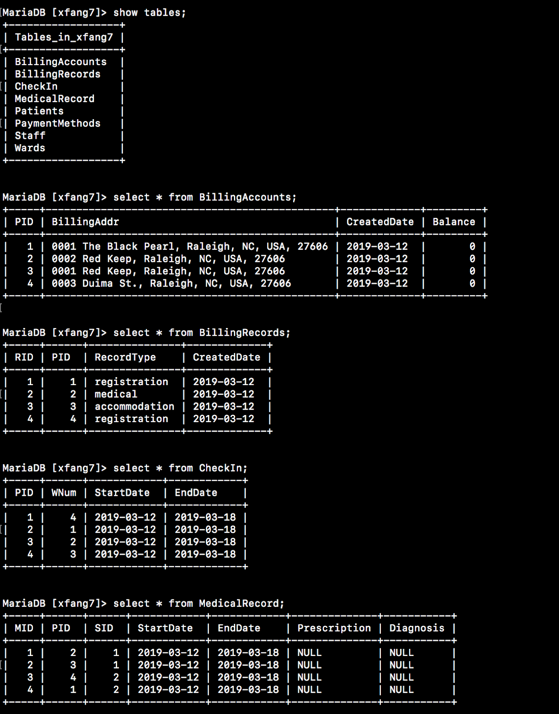

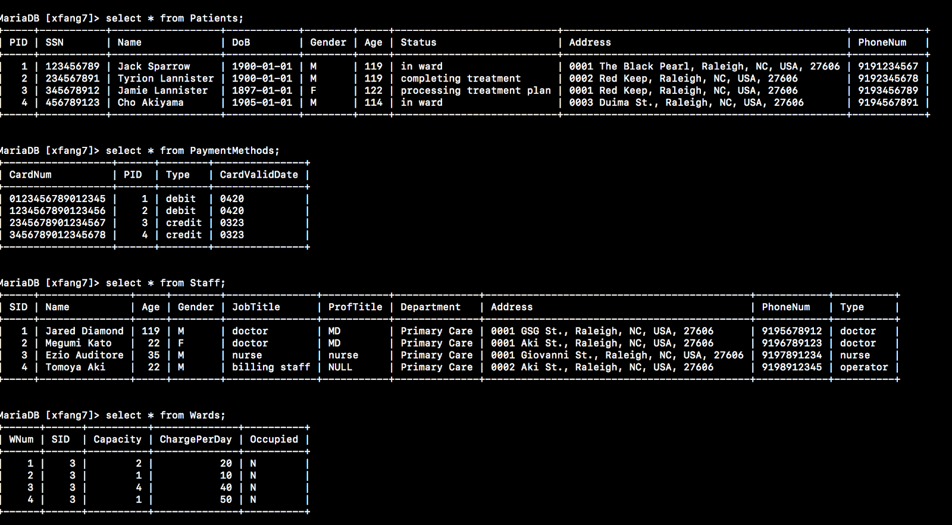

# 4) Interactive SQL Queries

Note: All results sets from select statements have been formatted for readability.

**4.1 Queries for tasks and operations**

*Also seen codes in* [*[github]*](https://raw.githubusercontent.com/MaggieFang/HospitalDBMS-CourseDBMS/master/src/CreateTable.java)*,method Name: infoProcess() and Origina pictures can be seen in the directory img of the project*

**4.1.1 Information processing**

**4.1.1 Insert & Update & Delete in Staff**

**4.1.2 Insert & Update & Delete in Patients**

**4.1.3 Insert & Update & Delete in Wards;**

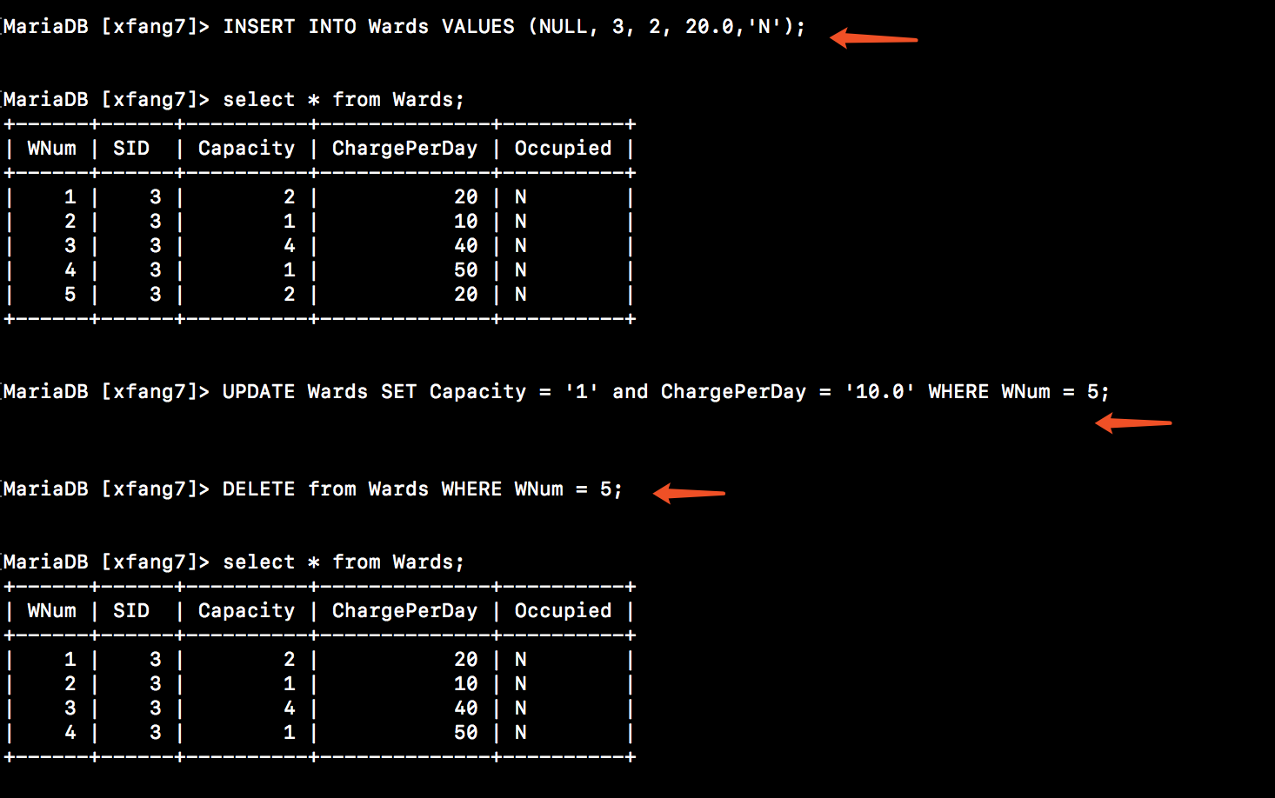

**4.1.4 Check Wards Information, Including the available wards. show information with bed num is 1 or 2 or 4;**

**4.1.5 Assume the request beds is 1 for Patient with PID = 1. Assign wards to him. It will include actions to find an available ward with Capacity = 1 and insert a row of CheckIn and Update the Wards Occupied field;**

**4.1.6 Assume the request beds is 2 for Patient with PID = 2. Assign wards to him. It will include actions to find an available ward with Capacity = 2 and insert a row of CheckIn and Update the Wards Occupied field;**

**4.1.7 Assume the request beds is 2 for Patient with PID = 3. Assign wards to him. It will include actions to find an available ward with Capacity = 4 and insert a row of CheckIn and Update the Wards Occupied field;**

**4.1.8 Release a ward. It will include actions to delete the row from CheckIn and Update the Wards Occupied field;**

**4.1.2 *Maintaining medical records***

**4.1.9 enter three Medical Records for patient with PID = 2 for check-in, test and treatments perspectively. And then update the three records.modify the startDate or Diagnosis.**

**4.1.3 *Maintaining Billing Accounts***

**4.1.10 we assume that once a new patient added. There will be a billing account binding to it.We create Billing Accounts for the patients with PID = 1,2,3,4; and update the address of PID = 1;**

**4.1.4 *Reports***

**4.1.11 report the medical records for patients with PID = 2;**

**4.1.12 report the medical records for patients with PID=2 in March,2019.**

**4.1.13 the usage of the wards that are Occupied, including details and Numbers.**

**4.1.14 the usage of the wards that are available, including details and Numbers.**

**4.1.15**the number of patients per month/year.

when a patient visited. He has a checkIn information in table CheckIn. So just group by Year-Month and count the PID. Results are shown below:

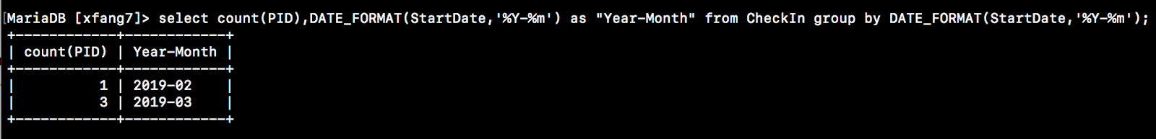

4.1.16 the ward-usage percentage.

4.1.17 information on all the patients a given doctor is currently responsible for.

find all the patients(PID,Name) that doctor with name “Jared Diamond” is responsible for.

4.1.18 Count the number of staff group by their roles and then show each group detail information.

**4.2 Autotrace and Indexes for two tables**

* The first index was added to Wards based on the "Occupied" column.

Before the creation of index, 4 rows are examined in the Wards table; after the index is created, only one row is examined.

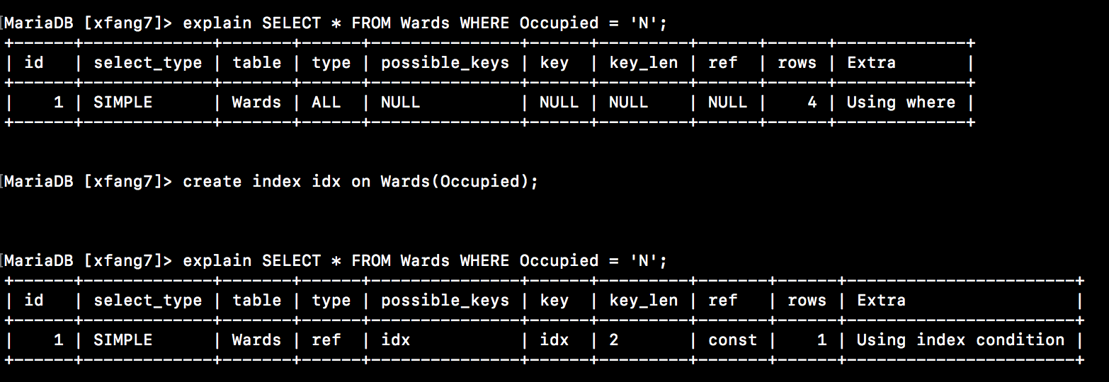

* The second index was added to Patients based on the "Name" column.

explain select * from Patients where Name="Jack Sparrow";

create index idx on Patients(Name);

explain select * from Patients where Name="Jack Sparrow";

Before the creation of index, we need to exam 4 rows in the Patients table, after that, we only need to exam 1 row.

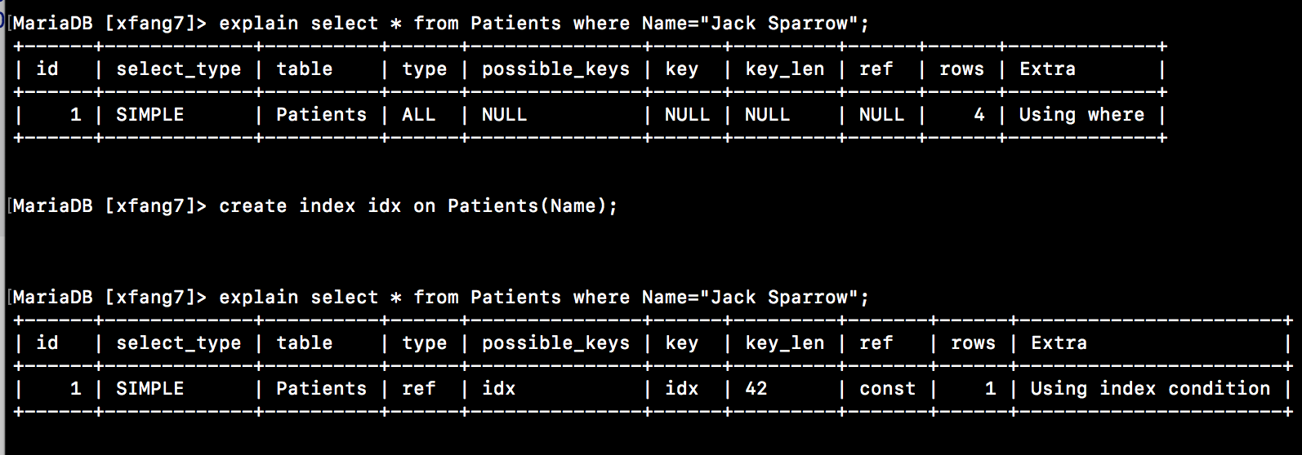

**4.3 Query correctness proofs**

**Query 1**

1. Specification: “find the charges per day of the ward which patient “Jack Sparrow” is living in”
2. SQL query:

select ChargePerDay from Wards inner join (Patients inner join CheckIn on CheckIn.PID = Patients.PID and Patients.Name="Jack Sparrow") on Wards.WNum = CheckIn.WNum;



1. algebra expression:
2. correctness proof:

Suppose d is any tuple in the distributors relation, and o is any tuple in the orders relation, such that the value d.acct is the same as the value o.distributor_id.  Each such combination of tuples (d, o) gives all information about the order, as well as corporate information about the distributor which made requested the order. For each such combination (d, o), the query returns the value of city and the value of price and copies.  These are the city of the distributor, the price per copy, and number of copies for the order. By multiplying price per copy by copy we obtain the total revenue per order. By then summing all total revenue in groups designated by the value of city, we obtain total revenue associated with each city.  But this is exactly what our query should return; see the specification.

**Query 2**

1. Specification: “find all the patients a given doctor “Jared Diamond” is responsible for”
2. SQL query:

select Patients.Name from Patients inner join (MedicalRecord inner join Staff on MedicalRecord.SID = Staff.SID and Staff.Name="Jared Diamond") on MedicalRecord.PID = Patients.PID;



1. algebra expression:
2. correctness proof:

Suppose s is any tuple in the *Staff* table, m M is any tuple in the *MedicalRecord* table, combine these two tables such that the value s.SID is the same as the value m.SID and s.Name is equal to the given doctor name.  Each such combination of tuples (s, m) gives all information about the medical records that such a doctor participates in. Then for such tuples (s, m) and p which is any tuples in the *Patient* table, combine these two tables such that the value p.PID is the same as the value m.PID, then the combination of tuples (s, m, p) returns the names of patients that a given doctor is responsible for.